**Conversation Workshop**

**Conversation Topic:** First Impressions

**Level:** A1-A2

**Speaking Activity 1:** *The Importance of First Impressions*

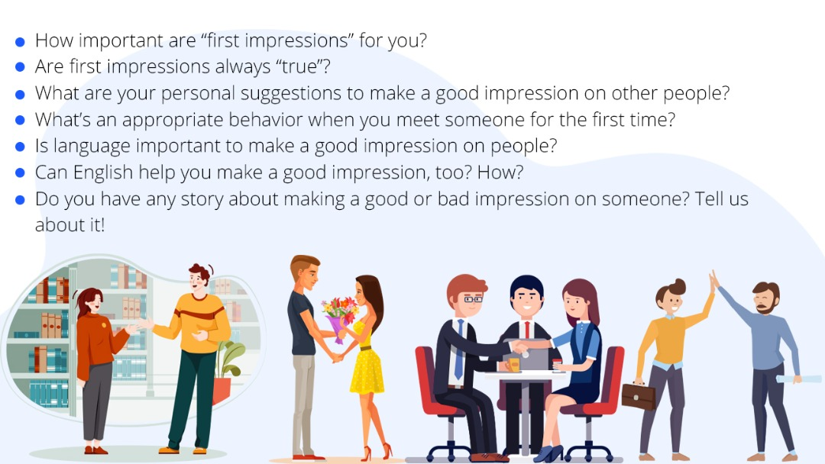

**Speaking Activity 2:** Punctuality

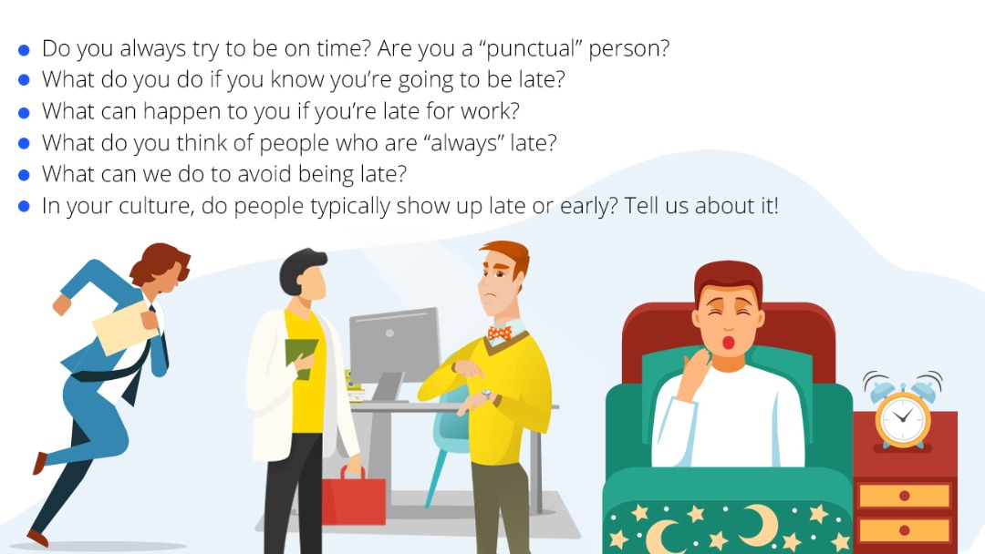

**Speaking 3: Body Language**

