**Vocabulary & Speaking Practice**

**Lesson:** *Photos from a Storm Chaser*

**Level:** B2

**Text From:** <https://www.youtube.com/watch?v=MgOVOCUuScE>

By Camille Seaman

**Warm Up**

* Are you afraid of storms?
* Do you happen to know what causes lightning?
* Is there any particular storm you remember for personal reasons? If so, what happened?

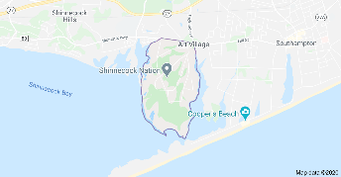**1. Vocabulary: Before you listen!**

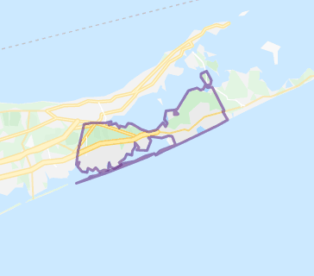**-** Shinnecock Indians Nation: a federally recognized tribe of Native Americans based at the eastern end of Long Island, New York.

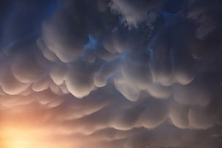- Southampton Town: a town in southeastern Suffolk County, New York, partly on the South Fork of Long Island. Southampton is included in the stretch of shoreline prominently known as The Hamptons.

- mammatus clouds: meaning "mammary clouds", they are a cellular pattern of pouches hanging underneath the base of a cloud, typically rainclouds, although they may be attached to other classes of parent clouds.

**2. Comprehension**

**Directions:** Watch the short video and answer the following questions:

**2.1. General Comprehension**

What nature subject does Camille explore and present?

**2.2. Specific Comprehension**

**a)** Which family remember relates to Camille’s storm chasing passion?

**b)** How does the presenter describe the storm chasing experience?

**c)** What comes to Camille’s mind when she stands under a storm?

**3. Pronunciation Practice**

**Directions:** Under your teacher’s supervision, read the video transcript aloud for pronunciation assessment.

*Everything is interconnected. As a Shinnecock Indian, I was raised to know this. We are a small fishing tribe situated on the southeastern tip of Long Island near the town of Southampton in New York.*

*When I was a little girl, my grandfather took me to sit outside in the sun on a hot summer day. There were no clouds in the sky. And after a while, I began to perspire. And he pointed up to the sky, and he said, "Look, do you see that? That's part of you up there. That's your water that helps to make the cloud that becomes the rain that feeds the plants that feeds the animals."*

*In my continued exploration of subjects in nature that have the ability to illustrate the interconnection of all life, I started storm chasing in 2008 after my daughter said, "Mom, you should do that."*

*And so, three days later, driving very fast, I found myself stalking a single type of giant cloud called the super cell, capable of producing grapefruit-size hail and spectacular tornadoes, although only two percent actually do. These clouds can grow so big, up to 50 miles wide and reach up to 65,000 feet into the atmosphere. They can grow so big, blocking all daylight, making it very dark and ominous standing under them.*

*Storm chasing is a very tactile experience. There's a warm, moist wind blowing at your back and the smell of the earth, the wheat, the grass, the charged particles. And then there are the colors in the clouds of hail forming, the greens and the turquoise blues. I've learned to respect the lightning. My hair used to be straight.*

*I'm just kidding.*

*What really excites me about these storms is their movement, the way they swirl and spin and undulate, with their lava lamp-like mammatus clouds. They become lovely monsters.*

*When I'm photographing them, I cannot help but remember my grandfather's lesson. As I stand under them, I see not just a cloud, but understand that what I have the privilege to witness is the same forces, the same process in a small-scale version that helped to create our galaxy, our solar system, our sun and even this very planet. All my relations.*

*Thank you.*

**4. Vocabulary Builder**

**4.1. Synonyms**

**Directions:** Say the underlined word/phrases some other way, according to the sentence context.

1. *Everything is interconnected.*
2. *As a Shinnecock Indian, I was raised to know this.*
3. *We are a small fishing tribe situated on the southeastern tip of Long Island*
4. *In my continued exploration of subjects in nature that have the ability to illustrate the interconnection of all life, I started storm chasing in 2008 after my daughter said, "Mom, you should do that."*
5. *And so, three days later, driving very fast, I found myself stalking a single type of giant cloud called the super cell, capable of producing grapefruit-size hail and spectacular tornadoes.*
6. *What really excites me about these storms is their movement.*
7. *When I'm photographing them, I cannot help but remember my grandfather's lesson.*
8. *As I stand under them, I see not just a cloud, but understand that what I have the privilege to witness is the same process in a small-scale version that helped to create our galaxy.*

**4.2. Word Families**

**Directions:** Complete the given re-expressionof thesentences below with **nouns** deriving from the underlined units.

1. *Everything is interconnected. (There’s ______________ in everything in nature)*
2. *As a Shinnecock Indian, I was raised to know this. (I got _________________ of this as I was raised)*
3. *When I was a little girl, my grandfather took me to sit outside in the sun on a hot summer day. (My father took me to sit outside in the Summer’s __________)*
4. *I found myself stalking a single type of giant cloud called the super cell, capable of producing grapefruit-size hail. (These clouds have the _______________ to produce hail.)*
5. *They can grow so big, blocking all daylight. (Their __________ can even block daylight)*
6. *There's a warm, moist wind blowing at your back (You can feel the wind _____________ at your back.)*
7. *I've learned to respect the lightning. (My ____________for lightning is something I’ve learned in time)*
8. *What really excites me about these storms is their movement. (My greatest _______________ is the storm movement).*
9. *When I'm photographing them, I cannot help but remember my grandfather's lesson. (When I took ___________ of them, I always remember my father.)*

**6. Speaking: Monologues!**

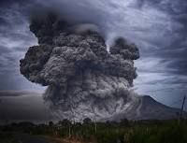**6.1. Natural Disasters**

a) Have you ever been in a natural disaster? If so, how was your experience like?

b) Which natural phenomenon is more frightening for you? Why?

c) How can people help after a natural disaster?

d) Have you ever volunteered to help in a disaster? If so, what did you do? Did you enjoy it?

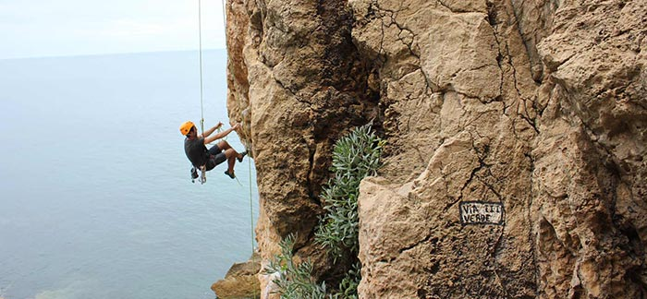**6.2. Risk Sports and Hobbies**

a) What’s the most dangerous sport or activity you’ve done? Tell us about it!

b) Why do you think people practice risk sports or have “less safe” hobbies?

c) Do you think that practicing extreme sports is an irresponsible thing?

d) What risk sport would you choose to practice (if any)?