**Lesson: What can I say about being a woman?**

**Upper Intermediate level**

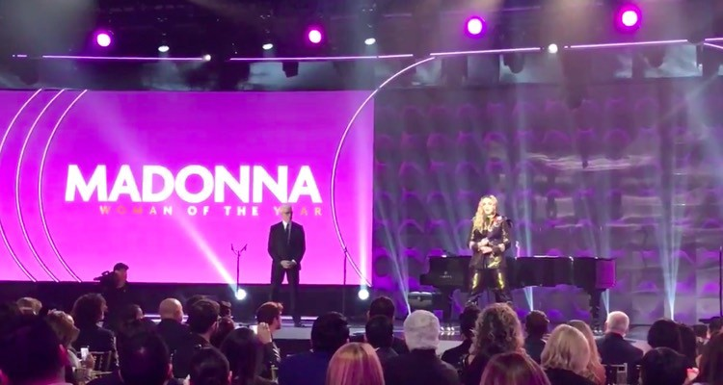**Transcript of Madonna’s 2016 “Woman of the Year Award” Speech at Billboard Music Awards**

**(Part 1)**

**Directions:** *Read the transcript out loud for pronunciation purposes. Pay closer attention to the highlighted chunks. Then, answer the comprehension questions below.*

“Thank you for acknowledging my abili*t*y to continue my career for thirty 34 years. When I star*t*ed, there was no Internet; so, people had to say it to my face. When I first moved to New York, I was a teenager. It was 1979 and New York was a very scary place.

In the first year, I was held up at gunpoint, raped on a rooftop with a knife digging into my throat. And I had my apartment broken into and robbed so many times I just stopped locking the door. In the years to follow, I lost almost every friend I had to AIDS or drugs or gunshot.

As you can imagine, all these unexpected events not only helped me become the daring woman that stands before you; but i*t* also reminded me that I am vulnerable. And in life, there is no real safety, except self-belief… and an understanding that I… I’m not the owner of my talents. I’m not the owner of anything.

Everything I have is a gift from God. And even the (------) things that happened to me, that still happen to me, are also gifts to teach me lessons to make me stronger. I’m receiving an award for being ‘woman of the year’; so, I asked myself: *What can I say about being a woman in the music business? What can I say about being a woman*?”

**Text Comprehension**

**1.** General Comprehension

**Question:** In few words, how do you consider Madonna’s journey to success has been?

**2.** Specific Comprehension

**a)** What negative experiences did Madonna have in New York during her teens?

**b)** What has she learned from his troubled life as a young woman?

**c)** What does she think of her talents?