**Level:** B1+

**Conversation Workshop B1-B2**

**Lesson Topics:** Animal Bonds

**Speaking 1 (Video-Based Activity):** Animal Bonds (20 min)

**Directions:** Take a moment to watch a short video and answer the questions below:

* What’s the video about? What’s the story told?
* ****How strong can be the bond between two animals? Any personal story to share in this regard?
* 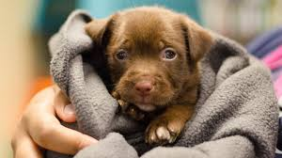What about the emotional bond between a person and an animal? How close do you think a human-animal relationship can get?
* Have you ever visited an animal shelter? Between buying or rescuing a pet, which option are you for?
* Psychologically speaking, what are the positive effects of adding a pet member to the family? What direct effect does it have, for example, on children?
* 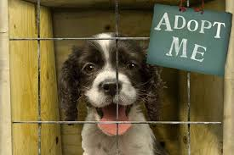What hygiene measure should be taken into account when bringing a pet home?
* What are your personal experiences when it comes to animal petting? Was there (or is there) any animal friend you’d like to talk about?

**Speaking Activity 2:** Exotic Animal Petting

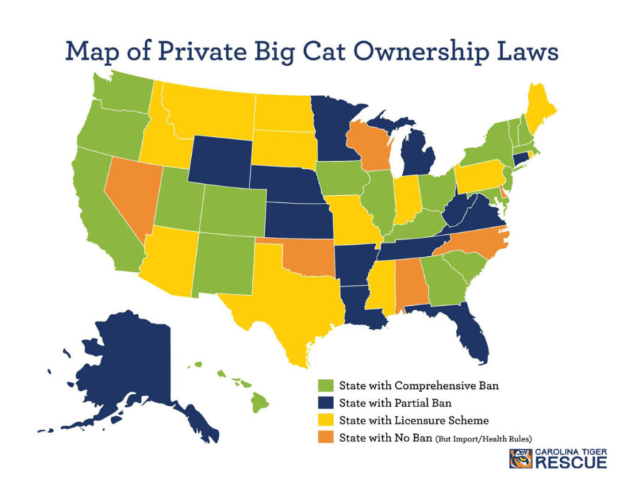**Directions:** Interpret the map and answer the questions that follow in the form of a brief monologue. Feel free to add any information you consider relevant to your presentation.

* What’s your personal opinion about petting an exotic or wild animal (such as a wild cat or a tiger)? Are you in favor or against this kind of activity?
* In your opinion, what psychological features could be associated to a person owning an exotic animal?
* What are the possible threats of taming a wild animal?
* How does living outside a natural habitat affect a wild animal’s life?

**Speaking Activity 3:** Animal Vs. Entertainment

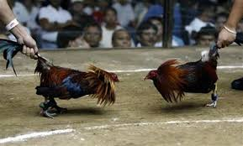**Directions:** Take a look at the pictures and answer the questions below in the form of a brief monologue:

* 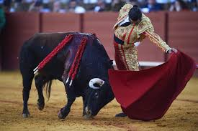Why do you think some people promote events such as: a cockfight, a bullfight, a dogfight or a killer whale show? What major benefit do you think is drawn from this type of exhibitions?
* 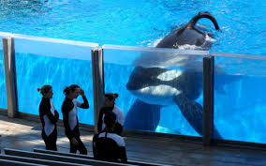In general, what’s your opinion about animal-based entertainment? Do you consider it a form of animal exploitation?
* What about the animals being kept in zoos and aquariums?
* Do you agree with certain animal rights activists fighting to ban these exhibition centers?