**Conversation Classes**

**Lesson: Holidays**

**Level: A2+, B1, B2**



**Speaking Activities 1: Holidays All Over the World**

* Do you like holidays?
* What holidays do you celebrate in your country?
* Are there enough holiday s in your country for which workers get the day or days off?
* What holiday is your favorite? Why?
* What holiday food do you like? Do you gain weight during certain holidays?
* Is there any special occasion or anniversary you think deserve to be a public holiday (but is not)?
* Is it better to stay at home on holidays or go somewhere?
* How would you feel if there weren’t any holidays?
* 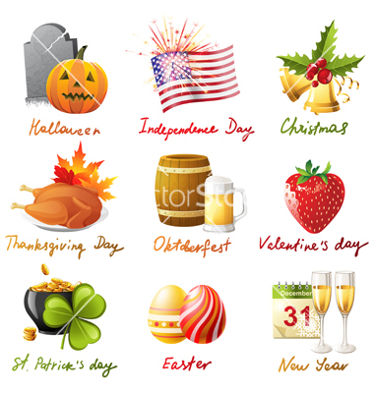Do you think there should be a world holiday for everyone on Earth to celebrate together?

**Speaking Activity 2: American Holidays**

* Do you know all of the American holidays represented in the picture?
* Which of these holidays do you celebrate in your country of origin?
* Is there any celebration that you wish was also celebrated in your country?
* Do you think that people always know the real meaning of all these celebrations?
* Do you think some of these holidays are too commercialized? If so, which ones?
* What do you think is the most overrated holiday?

**Speaking Activity 3: Travelling on a Holiday**

* Do people in your country typically travel on holidays? If so, tell us about it!
* What are the pros and cons of travelling on a holiday?
* What about you? Do you prefer travelling or staying at home during a holiday?
* Do air tickets get higher during holiday seasons? What’s your experience? Do you have any story to share about this?
* What about street accidents? Do you think they increase during the holiday season (November-December)? Why do you think this happens?
* What is a good destination in your country for holiday travelers? Which site would you recommend?
* What are your plans for New Year’s Eve? Are you going to travel anywhere? Tell us about it!