**ARCHES Language School**

**Conversation Workshops**

**Conversation Topic:** The Power of Our Mind

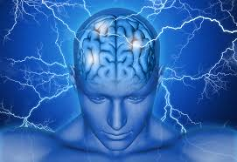**Speaking Activity 1:** **If you believe it, you can achieve it!**

**a)** Do you believe in the power of human mind?

**b)** Do you think that positive thoughts can attract amazing experiences?

**c)** What about negative thinking? Do you believe that negative thoughts can create a wall of “bad energy” around you that will eventually bring adversity into your life?

**d)** Have you had any personal experience where you were able to change realitythrough positive thinking? Tell us about it!

**Speaking Activity 2: Overcoming Fear or Pain**

**a)** Do you believe our brain can help us overcome situations of fear or pain? How could our mind help us block those sensations?

**c)** It is said that anxiety has much to do with fear. In this regard, what mental exercise do you think could help us fight fear or anxiety? Have you had any personal experience where you’ve had to use your mind to defeat such feelings?

**d)** It is known that some people overcome pain without even taking pills. Aside from the use of natural medicine, how do you think that’s possible?

**e)** Overall, do you think fear can be killed at the same place where it comes from (our brain)? Likewise, do you think our mind has the power to naturally heal our body? Tell us your conclusion!

**Speaking Activity 3:** **Mind Vs. Actions**

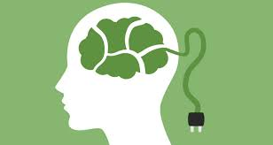**a)** It is said that “there’s a difference between what you want and the actions you are capable of taking”. What’s the relation between “what we think” and “what we do”? What does this phrase mean to you?

**b)** Do you think that justbecause“we really want or desire something” we will be able to get it at some point in our life?

**c)** What should our attitude and behavior be like if we want to transform a desire into a reality?

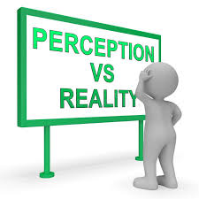**d)** We all know thatevery goal or purpose starts with aprimary thought.In your opinion, how does *determination*, *discipline* and *consistency* influence the fulfillment of a goal?

**e)** Have your actions always been aligned with your thoughts? Tell us about it!