**Conversation Class**

**Teaching Strategy:** Error Correction on Spontaneous Speech

**Language Topic:** Recycling and Reusing

1. **Recycling**

**Read the following facts according to the the EPA (Enviromental Protection Agency)**

|  |
| --- |
| **Is recycling truly beneficial for the environment?** [EPA data](https://www.epa.gov/facts-and-figures-about-materials-waste-and-recycling/advancing-sustainable-materials-management) show that recycling con serves energy and natural resources. For example:   * Recycling one ton of office paper can save the energy equivalent of consuming 322 gallons of gasoline. * Recycling just one ton of aluminum cans conserves more than 152 million Btu, the equivalent of 1,024 gallons of gasoline or 21 barrels of oil consumed. * Plastic bottles are the most recycled plastic product in the United States as of 2015, according to our [most recent report](https://www.epa.gov/facts-and-figures-about-materials-waste-and-recycling/advancing-sustainable-materials-management). [Recycling](https://www.epa.gov/recycle) just 10 plastic bottles saves enough energy to power a laptop for more than 25 hours. |

* Do you recycle? If so, what do you recycle? Plastic? Paper? Glass? All of them?
* 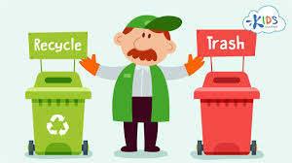If so, when did you start recycling?
* What other facts do you know about the direct and indirect effects of recycling on the environment?
* Do you teach your children to recycle?
* In your opinion, what’s the difference between recycling and non-recycling societies?

2. **Reusing**

* What’s the difference between reusing and recycling? How would you define “reusing”?
* 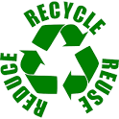How do you think reusing helps preserve the environment?
* What do you reuse for saving purposes? Storage boxes? Shopping bags? Glass jars? Clothes? Newspapers and magazines?
* How much waste do you and your family produce at home? Do you think you’d need to reduce the amount of waste you’re currently producing?
* How do you think reusing could help your personal finances?
* Do you have any personal story about how reusing (or recycling) change your life (or somebody else’s)?