**ARCHES Language School**

**Level:** B2-C1

**Lesson:** Lonely no more!

**Language Focus:** Vocabulary Building, Pronunciation, Speaking.

**1.** **Warm Up**: Getting Ready! (5 mins)

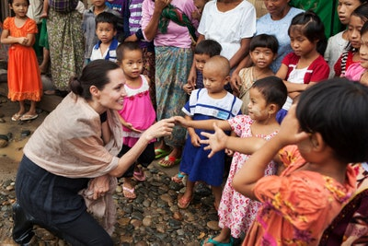

Many celebrities around the world have turned out to be powerful activists throughout the 21st century. These are just few examples to mention:

* 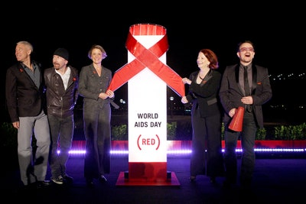Since 2001, Angelina Jolie has worked with children in need in more than 30 countries, going on missions on behalf of the United Nations.
* In 2016, Bono founded the (RED) project to help raise awareness of AIDS and AIDS relief in Africa.
* DiCaprio has long been one of the famous environmentalists in Hollywood. He founded the Leonardo DiCaprio Foundation in 1998, which focuses on a variety of climate and indigenous-rights issues.

**Question:** *Do you know about any famous person and the cause that she/he fights for?* Tell us about it!

|  |
| --- |
| In today’s lesson, you will know about the story of Kavaan, “the world’s loneliest elephant”, rescued by a well-known superstar from being kept in unproper conditions. |

**2. Vocabulary**: Before you listen! (5 mins)

**Directions:** Before watching today’s class video, make sure to get familiar with the following words and phrase to ensure comprehension.

* **be on the decline** /dɪ-ˈklaɪn/ (v. ph.): becoming worst in condition

**Ex.:** The elephant’s health *was on the decline*.

* **advocate** /ˈad-vō-ket/ (n.): a public supporter or activist.

**Ex.:**  Animals *advocates* say animals the elephant was suffering.

* **sanctuary** /ˈsank-chu-e-ri/ (n.): a shelter for wildlife where predators are controlled and hunting is illegal.

**Ex.:** The elephant was taken to a *sanctuary*.

* **crate** /kreɪt/ (n.): a wooden case used for transporting goods.

**Ex.:** The elephant was put in a *crate* inside a plane.

* **quarantine** /ˈkuō-ran-tiin/ (v.): be kept apart from others for a period of time to prevent the spread of any disease.

**Ex.:** The elephant will *quarantine* before being released.

* **befriend** /bi-ˈfrend/ (v. i.)**:** act as a friend to someone.

**Ex.:** Kavaan will meet the other elephants that he’ll hopefully *befriend*.

**3.** **Video Watching** (10 mins)

**Directions:** Watch the short video about the World’s Loneliest Elephant and follow the directions on the page.

**3.1. General Comprehension**

a) Which celebrity rescued the World’s Loneliest Elephant in the video?

b) Where was the elephant kept before being rescued?

c) Where was the elephant finally taken for recovery?

**3.2.** **Specific Comprehension**

a) How long was Kavaan living in inadequate conditions?

b) Did he ever have a partner? If so, what happened to her?

c) What did the superstar do before Kavaan’s departure to a better place?

d) How was he transported?

e) Who welcomed Kavaan at his destination?

**3.** **Video Transcript** (5 mins)

**Directions:** Under your teacher’s supervision, read the video transcript aloud for pronunciation assessment.

*The world's loneliest elephant will be lonely no more! Thanks to superstar Cher, who couldn't let him spend the rest of his days alone.*

*Kavaan spent 35 years living in abysmal conditions at a zoo in Pakistan, where he was only taken out of his cage for performances, according to his rescuers. Things got worse for him about eight years ago, when his partner died from an infection. Since then, animal advocates say his mental and physical health has been on the decline, and they pushed for him to be retired to a sanctuary.*

*This week after years of advocating for Kavaan, Cher got to see him leave Pakistan for his new life in Cambodia. She fed him some fruit and sang to him before his long journey.*

*Then Kavaan was loaded onto a crate and put on a plane for a 10-hour flight. Cher was waiting for him when he landed in Cambodia to welcome him to a better future. Her organization, Free the Wild, worked with Animal Welfare Group, Four Paws and other donors to help make this rescue happen.*

*Kavaan was then loaded onto a truck and taken to the sanctuary, where he will quarantine before being released to meet the other elephants that he will hopefully befriend. After years of suffering, finally, a happy ending.*

*For Inside Edition Digital, I’m Mara Montalbano.*

**4.** **Vocabulary** **Practice** (15 mins)

**4.1.** **Synonyms (Orally)**

**Direction:** Say the underline words and phrases another way to enrich your vocabulary.

1. The world's loneliest elephant will be lonely no more.
2. Kavaan spent 35 years living in abysmal conditions at a zoo in Pakistan,
3. Things got worse for him about eight years ago, when his partner died from an infection.
4. Since then, animal advocates say his mental and physical health has been on the decline.
5. They pushed for him to be retired to a sanctuary.
6. She fed him some fruit and sang to him before his long journey.
7. Kavaan was loaded onto a crate and put on a plane for a 10-hour flight.
8. Her organization and other donors helped to make this rescue happen.
9. He will quarantine before being released to meet the other elephants that he will hopefully befriend.
10. After years of suffering, finally, a happy ending.

**4.2. Word Families**

**Directions:** Complete the second sentence with a word from the family of the word **highlighted** in the original sentence. The first example has been done for you.

1. The World's Loneliest Elephant will be **lonely** no more!

**Answer:** *The World’s Loneliest Elephant will say goodbye to loneliness (noun)!*

1. Kavaan was only taken out of his cage for **performances**.

**Answer:** Kavaan was only taken out of his cage to ______________ (verb) in front of people

1. *Things got worse for Kavaan when his partner* ***died*** *from an* ***infection****.*

**Answer:** *Things got worse for Kavaan after his partner* ___________ (noun), who got _______________ (adj.) with lethal bacteria.

1. Animal **advocates** say his **mental** and **physical** health has been on the decline.

**Answers:** Animal activists ____________ (verb) that Kavaan is ______________ (adverb) and ______________ (adverb) affected.

1. They pushed for him to be **retired** to a sanctuary.

**Answer:** They pushed for Kavaan’s _______________ (noun) at a sanctuary.

1. Cher was waiting for him when he **landed** in Cambodia to **welcome** him.

**Answer:** Cher was waiting for him at his _____________ (noun) for a warm _____________ (noun).

1. Her organization worked with other donors to make this **rescue** happen.

**Answer:** Her organization worked with other donors to be able to ____________ (verb) Kavaan.

1. Kavaan will **quarantine** before being **released** to meet the other elephants.

**Answer:** Kavaan will be put under _________________ (noun) before his ______________ (noun) at the sanctuary.

1. After years of **suffering**, finally, a **happy** ending.

**Answer:** After having ______________ (verb) a lot, Kavaan will live _________________ (adv.) ever after.

**5.** **Speaking**: Presenting a monologue! (15 min)

**5.1. Animal Petting**

* 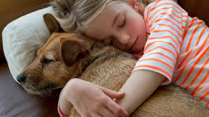How strong can be the emotional bond between a person and an animal? How close do you think a human-animal relationship can get?
* 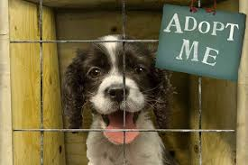Have you ever visited an animal shelter? Between buying or rescuing a pet, which option are you for?
* What are the positive effects of adding a pet member to the family? How do they affect, for example, children’s life?
* What are your personal experiences when it comes to animal petting? Was there (or is there) any animal friend you’d like to talk about?

**5.2. Animal Entertainers**

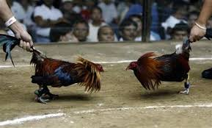**Directions:** Take a look at the pictures and answer the questions below in the form of a brief monologue.

* 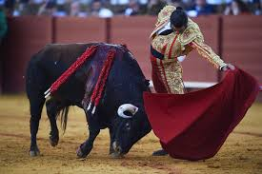Why do you think some people promote events like a cockfight, a bullfight, a dogfight or a killer whale show? What major benefits do you think are drawn from this type of exhibitions?
* In general, what’s your opinion about animal entertainment? Do you view it as a form of animal exploitation?
* 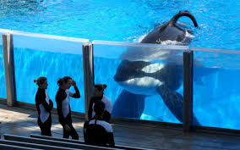What about the animals being kept in zoos and aquariums?
* Do you agree with certain animal rights activists fighting to ban these exhibition centers?