Level: A1
Module 1: Jobs and Daily Schedules
Lesson 3: How do you spend your day?

By the end of this lesson, the student should be able to:
- Identify other people’s occupations and daily schedules.
- Recognize lexical items related to the contents of the unit.
- Listen for general and specific information from an audiotext.
- Repeat with accuracy the content of the lesson audio text.
- Make questions in simple present tense (Yes/No & WH).
- Retell the situation presented in an audiotext following a model.

Warm up (5 min)
What questions do you ask when you want to know about:
- a person’s job?
- a person’s address?
- a person’s family?
Do you face communication issues when you need to ask questions in English language? Explain your answer.

Activity 13. Vocabulary (10 min)
13.1. Daily Activity Verbs
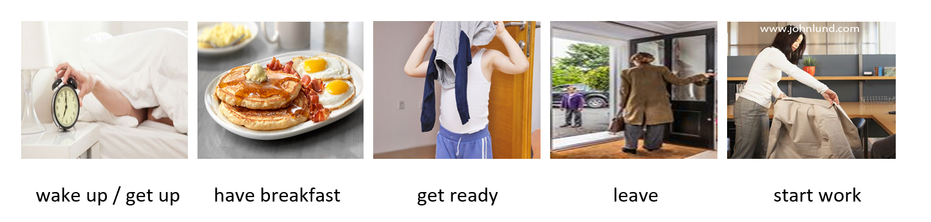
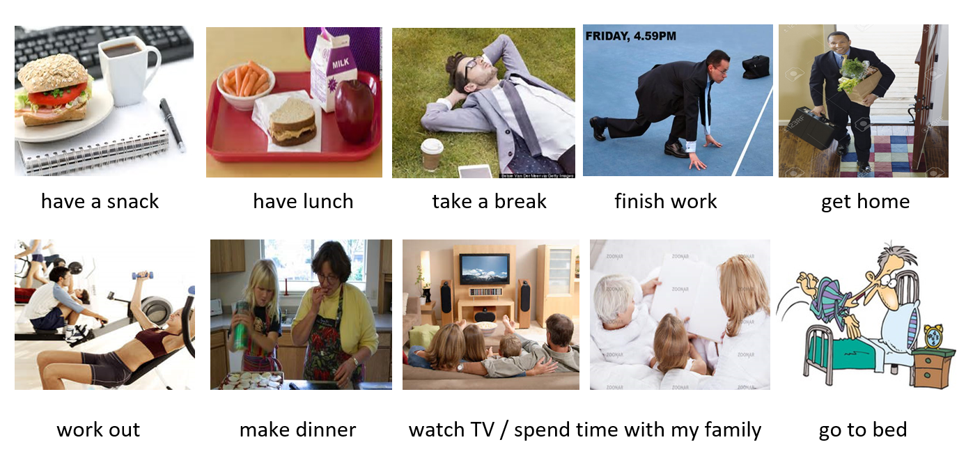

13.2. Linking Words
When we talk about the activities that we do every day, we use words or phrases that express sequence to better relate our ideas. These words or phrases make our speech more fluent and coherent. They generally occur at the beginning of sentences followed by a comma, but note that they can also be placed in the middle or the end of sentences. For example:
- First, I have breakfast. / I first have breakfast. / I have breakfast, first.
- Then, I go to my office. / I then go to my office. / I go to my office then.

See the chart below for more examples of linking words and phrases expressing sequence:
Sequence Word | Pronunciation | English Meaning | Spanish Equivalence
first | /ferst/ | in the first place | primeramente
then | /dhen/ | next, following something | entonces
after that | /af-ter-dhat/ | next, following something | después
finally | /faɪ-na-lɪ/ | last | finalmente

Activity 14. Listening Comprehension (5 min)
14.1. Listen to Helen and Daniel talk about their daily schedules. Who shares more information about his/her weekday routine?
A. Helen
B. Daniel
C. None

14.2. Listen to the conversation again and answer the following questions.
- What time does Helen get up on weekdays?
- What time does Helen have lunch?
- What time does Helen start work?
- What time does she get home?
- What does Helen do for work?

Activity 15. Conversation Transcript: Say it correctly! (5 min)
Directions: Under your teacher’s supervision, read the conversation transcript out loud for pronunciation purposes. Take into consideration the phonetic features indicated below:
Blending Flapped t or d

Daniel: How do you spend your day, Helen?
Helen: Well… on weekdays, I get up around 10:00. Then, I read the paper for an hour,
and have lunch at about noon.
Daniel: Really? What time do you go to work?
Helen: I start work at 3:00.
Daniel: And, when do you get home at night?
Helen: I get home pretty late, around midnight.
Daniel: So, what do you do, exactly?
Helen: I do the weather report on TV.
Daniel: I’m sorry. I don’t watch TV.

Activity 16. Grammar: Making Questions in Simple Present. (10 min)
1. Types of Questions (According to Form)
TYPES OF QUESTIONS
(according to the form)
Y/N Questions: The expected answer is always affirmative or negative (Yes/No). Example: Do you work on Mondays?

WH Questions (Information Questions): They begin by WH-words (what, when, etc.) and the answer requires extended information. Example: When do you work?

16.2. Yes/No Questions
In order to make yes/no questions in Simple Present, we use auxiliary verb do at the beginning of the sentence, before the subject. Example:
- Do you get up late? Short Answer: Yes, I do. /No, I don’t.
In the case of the 3rd person singular (She/He/It), auxiliary verb do becomes does.
- Does she start work at 7:00? Short Answer: Yes, she does. / No, she doesn’t.
Y/N Question Form: Do + Subject + Main Verb (simple form) + Object(s)?
Short Answer form: Yes/No + Subject Pronoun + do/does (+ not, if negative)

16.3. WH Questions (Information Questions)
We also use auxiliary verb do/does to make wh-questions in simple present tense, also called information questions because they say what, when, where, who, how, etc. Example:
- Where do you work? What do you do on weekdays?
- Where does she/he do on weekdays? Where does she/he work?
WH Question Form: WH Word (Ex: what, when, where, who, how) + do/does + Subject + main verb (simple form) + Objects?

Activity 17. Grammar Practice: Making Questions in Simple Present. (15 min)
Directions: Read what Jane says about her routine on weekdays. Then, make questions about Jane’s life as indicated in the exercises below.
“On weekdays, I get up very early… at 6:00 in the morning. Then, I have breakfast very quickly and get ready to leave. I leave at 7:00 because I don’t have a car and I take a bus. I get to my office around 8:00, but I don’t start work until 8:30am. At noon, I take a lunch break for an hour; and right after lunch, I get back to my desk. I finish work at 5:00 pm; and finally, go home. I get home by 6:00 in the evening, very tired. Finally, I go to bed pretty early about 10:00 at night.”
17.1. Making Yes/No Questions
Does she get up late ? No, she doesn’t. She gets up very early.
_______________________________________? Yes, she does. She has a quick breakfast.
_______________________________________? No, she doesn’t. She leaves at 7:00.
_______________________________________? No, she doesn’t. She takes a bus.
_______________________________________? Yes, she does. She has lunch at noon.
_______________________________________? No, she doesn’t. She works until 5:00.
_______________________________________? Yes, she does. She gets home tired.
_______________________________________? No, she doesn’t. She goes to bed by 10:00pm.

17.2. Making WH Questions
- What time does Jane get up on weekdays ? Very early, at 6:00 in the morning.
- _________________________________________? At 7:00am.
- _________________________________________? Because she doesn’t have a car.
- _________________________________________? She gets to the office around 8:00.
- _________________________________________? At 8:30 am.
- _________________________________________? She takes a break around noon.
- _________________________________________? She finishes work at 5:00pm.
- _________________________________________? By 6:00 in the evening.
- _________________________________________? About 10:00 at night.

18. Speaking (10 min)
18.1. Making Questions (Orally)
Directions: What question would you ask someone if you wanted to get the following information from him/her? More than one answer is possible. You can make either Yes/No or WH questions. The first two examples have already been done for you:
INFORMATION | SIMPLE-PRESENT QUESTION
a) place of residence | Where do you live?
b) means of transportation | How do you go to work? Do you have car?
c) work place
d) occupation
e) break time
f) number of children
g) after-work activities
h) music likes
i) food likes
j) fitness activity
k) number of languages spoken
l) smoking habits
m) weekend activities

18.2. Re-telling (10 min)
Directions: Tell about Helen’s routines from the information given in the conversation above. Make sure to avoid using introductory phrases like: “He asks…, She answers…, etc”.
Ice braker: Jack wants to know about Helen’s routine. She gets up…

Lesson 03: How do you spend your day?
Lesson Answer Key

Page 17 / Activity 14: Listening Comprehension
(Answers may vary.)

2.1. Listen to Helen and Daniel talk about their daily schedules. Who shares more information about his/her weekday routine?
Correct Answer: A. Helen

2.2. Listen to the conversation again and answer the following questions.
- What time does Helen get up on weekdays?
Possible Answer: She gets up around 10:00.
- What time does Helen have lunch?
Possible Answer: She has lunch at around noon.
- What time does Helen start work?
Possible Answer: She starts work at 3:00.
- What time does Helen get home?
Possible Answer: She gets home late, around midnight.
- What does Helen do for work?
Possible answer: She’s a TV announcer.

Page 19 & 20 / Activity 17: Grammar Practice
Activity 17.1: Yes/No Questions
(Answers may vary)
- Does she get up late _ ? No, she doesn’t. She gets up very early.
- _______Does she have/eat breakfast _______? Yes, she does. She has a quick breakfast.
- _______Does she leave at (8:00)___________? No, she doesn’t. She leaves at 7:00.
- _______Does she drive/have a car?_________? No, she doesn’t. She takes a bus.
- _______Does she have lunch_____________? Yes, she does. She has lunch at noon.
- _______Does she work until (3:00)_________? No, she doesn’t. She works until 5:00.
- _____ _ Does she get home tired__________? Yes, she does. She gets home tired.
- _______Does she go to bed late___________? No, she doesn’t. She goes to bed by 10pm.

Activity 17.2.: WH Questions
(Answers may vary.)
- What time does Jane get up on weekdays ? Very early, at 6:00 in the morning.
- ____What time does she leave ___________________? At 7:00am.
- ____Why does she leave at 7:00__________________? Because she doesn’t have a car.
- ____What time does she get to her office___________? She gets to her office around 8:00.
- ____What time does she start work_______________? At 8:30 am.
- ____What time/When does she take a break_ ? She takes a break around noon.
- ____What time/When does she finish work_________? She finishes work at 5:00pm.
- ____What time/When does she get home? _________? By 6:00 in the evening.
- ____What time does she go to bed________________? At about 10:00 at night.

Page 20 / Activity 18
(Answers may vary.)
INFORMATION | SIMPLE-PRESENT QUESTION
c) workplace | Where do you work?
d) occupation | What do you do for work?
e) break time | What time do you take a break?
f) number of children | How many children do you have?
g) after-work activities | What do you do after work?
h) music preference | What music do you prefer?
i) food likes | What food do you like?
j) fitness activity | Do you (do) exercise?
k) number of languages spoken | How many languages do you speak?
l) smoking habits | Do you smoke?
m) weekend activities | What do you do on weekends?

