**Arches Language School**

**Conversation Workshop 3: Holidays/ Vacations**

**Language Level:** A1

**Grammar Focus:** Simple Past and S. Present, Gerunds: ING for activities, Adverb Use.

1. **Speaking Activity:** Do you travel a lot? (25 mins)

|  |
| --- |
| **Directions:** In this speaking activity, you’ll listen to your teacher talk about her typical holidays/vacations. Then, in turns, talk about yours. The following questions may serve you as a basis, but feel free to add any information you consider relevant to your presentation. |

* Do you like holidays? If so, what’s your favorite type of vacation?
* What do you usually do? What activities do you enjoy?
* Do you like swimming in a pool or in the ocean?
* Do you travel by yourself or with your family/ friends?
* Do you enjoy travelling? In the summer or during winter season?
* How often do you take vacations?
* Are you afraid of flying?
* Do you usually take long trips? If so, tell us about your experience.
* Do you think it’s important to go to museums when you visit a new city? Explain your answer.
* Do you think that expensive trips are more enjoyable?
* Do you like trying out food in the new places you visit?
* Do you like booking tours with a guide?
* Do you practice any other language when you travel?

1. **Reading and Speaking Activity** (20 min)

(From: Conversation in Action. Let´s talk by Edward R. Rosset)

|  |
| --- |
| **Directions:** In this activity, you’ll hear your teacher read this short passage. Listen to the pronunciation and then answer the questions. There may be some new vocabulary for you, so ask your teacher about the meaning of any new word if you can´t guess from the context. |

**Holidays / Vacations**

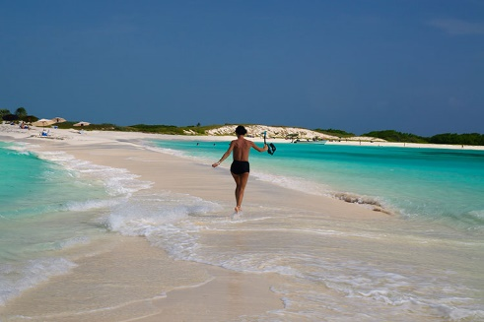Some people like to have their holidays/vacations organized. They book a year in advance so they know which hotel they´re staying at, how much it is going to cost, what the beach is like, what the food is like and what souvenirs they are going to buy.

Others like to go into the unknown world without any foresight. They take the car and stop wherever they like. They sleep in their own caravan or in a cheap hotel. These are the adventurous types, usually with a couple of children. They are always looking for a nice deserted beach all for themselves. There is the third type - people who are much more intrepid. These are the ones that sail around the world in a small yacht; trek across the Pyrenees; cross over the Alps following Hannibal´s trail; or do an 8,000m.climb in the Himalayas.

**Questions:**

* What do some people like?
* How long in advance do they book the hotel?
* Do they know how much the hotel is going to cost?
* Do they know what the food is like?
* Some other people take their own car, where do they stop?
* Where do they sleep?
* Do these people have any children?
* What are they always looking for?

1. **Speaking Activity 3:** (15 min)

|  |
| --- |
| **Directions:** In this speaking activity, you’ll share about different activities there are for tourists in your city. The questions below may serve as a basis for your presentation, but feel free to add any information you consider relevant. |

* What city do you live in?
* What are the most important places to visit in your cities?
* Is it expensive for tourists?
* Are there any museums? What are they about?
* Are there any beaches or mountains nearby? How far are them from your house?
* What is your idea of a perfect trip?