**Conversation Topics / Level:** B1 B2

**Lesson Topic:** Adoption

**My Country’s Policies on Adoption**

* What are the views of adoption in your country? Are adoptions common?
* 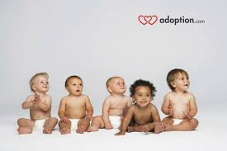How would someone interested in adopting a child go about doing so?
* Are people able to adopt a child of a different race?
* 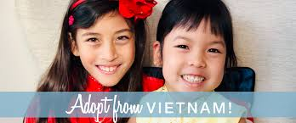What are the legal consequences of adopting a child from a different race or country?
* Are prospective parents in adoption required to do a parenting course?
* Does your country’s adoption policy allow birth parents to be involved in the adopted child's life?
* What are some organizations that help with adoptions?
* Do you believe there is discrimination within the adoption organizations?
* Are legal rights of an adoptive child different from those of a birth child?

**My Personal Views on Adoption**

* What do you think are some of the reasons people choose to adopt?
* 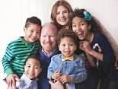Are there any risks when adopting a child?
* Should you tell the child that he or she was adopted? Do you think people who have been adopted should always have the right to find out who their birth-parents are?
* Should families with birth children also adopt?
* 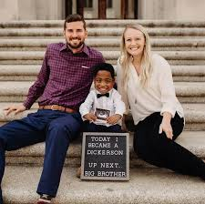Should adoptions be between children and families of the same race and or culture?
* Should a gay or lesbian couple be allowed to adopt a child? Should a single man or woman be able to adopt a child?
* Should there be an age restriction for the adoptive parents?
* Do you think brothers and sisters should be separated in adoptions?

**My Experience on Adoption (Factual and Hypothetical)**

* Do you know anyone who was adopted as a child?
* Do you know anyone who has adopted a child?
* If you found out I was adopted, would you want to find your birth family? Why or why not?
* ****Would you consider the idea of adopting a child?
* How would you feel if a child you had adopted wanted to search for his or her birth parents?
* Do you think it is preferable to adopt or to use artificial reproduction technology?
* What makes a family, genetics or environment?