**Oral Workshop: School Years**

**Topic 1: Friendship**

|  |
| --- |
| *Watch the inspirational video (Video 1) for this topic and present a monologue about the role of friendship in your life. The following questions may serve as a guideline for your presentation, but feel free to add any information you consider relevant to your presentation.* |

* 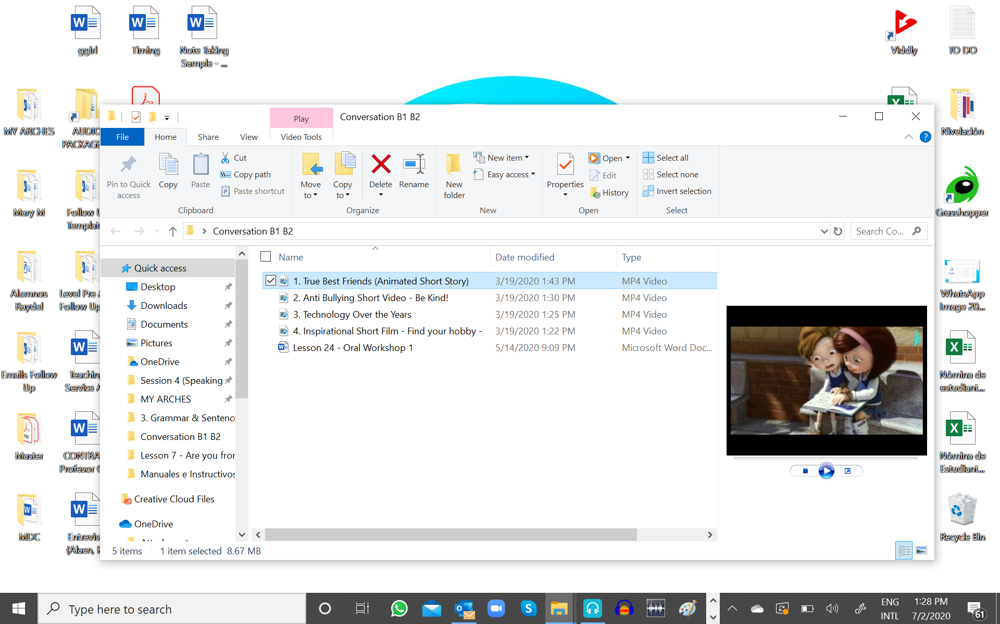How important are friends for you?
* What would your life be like without your friends?
* Can a friend be there for you as a family member?
* When you think of your best friend, who do you think of? What can you tell us about your best friend?
* How did your friendship begin?

**Topic 2: School Bullying**

|  |
| --- |
| *Watch the inspirational video (Video 2) for this topic and present a monologue about the impact of bullying in a young person’s life.  The following questions may serve as a guideline for your presentation.* |

* 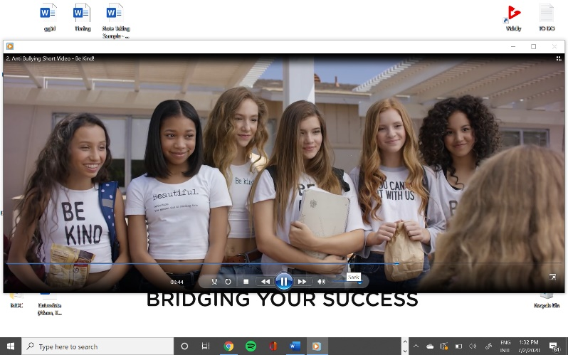Do you know what bullying is? How could you define it in your own words?
* How do you think bullying can affect a young person’s life?
* Do you know someone who have been a victim of bullying at some point in his/her life? What can you tell us about his/her experience?
* How can we help stop bullying? Share some ideas with your teacher.

**Topic 3: Finding One’s Vocation**

|  |
| --- |
| *Watch the inspirational video (Video 3) for this topic and present a monologue about finding one’s vocation and choosing a career path.  The following questions may serve as a guideline for your presentation.* |

* In your case, how can a person find his/her vocation and, subsequently, choose a career path?
* What factors can influence this life decision?
* In your case, what things did you take into account when choosing your career field? Your interests, soft skills, aptitudes, or your personality?
* Should we follow advice or our instincts? Would it be useful to consider other people’s experiences or build your own?
* What should we base our final decision on? Our future earnings or our true vocation?