**Lesson: Artificial Intelligence**

**Module:** Business Matters

After-listening Activities

**3. Comprehension**

**Directions:** Listen to the audio text for the second time -if necessary- and answer the following questions:

* How does the text define artificial intelligence?
* Is the study of artificial intelligence something recent?
* What are some examples of “artificially intelligent machines”?
* What are some of the institutions leading important research on artificial intelligence?

**4. Vocab Practice (Transcription)**

**Directions:** Read the audio text transcript under your teacher supervision. As you read, think of possible synonyms for the underlined words and phrases.

Do robots have the same characteristics as humans? Which is more intelligent—man or machine? The debate is ongoing.

Humans are capable of several traits. Among them are reasoning, planning, learning, and communication. Are computers and machines capable of the same traits? Essentially, the definition of artificial intelligence is the intelligence that a machine demonstrates. With the onslaught of robots, computers, and other technological advances, one might believe the study of artificial intelligence is new. However, people have been working on intelligent machines for years. One of the more famous names associated with the field is Alan Turing. Turing believed that if a machine could pretend to be human, then it was intelligent.

One thing that people can do with artificial intelligence is play games. Machines are available that play chess at expert levels. They’re not even that costly. Turing wrote the first computer chess program in 1950; however, it wasn’t until 1958 that a chess program beat a human for the first time. Over the years, computers began playing in tournaments with some wins and some losses. As the years progressed, computers started winning more and more. In 2005, a team of computers beat chess champions Veselin Topalov, Ruslan Ponomariov, and Sergey Karjakin.

Many industries, such as airlines and technology, are incorporating artificial intelligence into their work. AT&T lists artificial intelligence as one of its research areas. Universities such as Carnegie Mellon, Massachusetts Institute of Technology (MIT), and Stanford University have done research in the field. MIT has CSAIL (Computer Science and Artificial Intelligence Laboratory). One of the lab’s research areas is an attempt to understand and develop artificially intelligent behavior. A lot of the research is done by faculty members who work with students. Some US government agencies help fund CSAIL.

As industries experiment and researchers study, the public has become more aware of the possibilities. The movie industry has made several films that usually are classified as science fiction. One popular film was *I, Robot.* Another was simply titled *Artificial Intelligence*. People have also started buying toys and tools that display certain traits. *The Furby™* was a popular robotic toy that eventually learned to speak English. The *Roomba™* is a vacuum that is made by the iRobot Corporation. It vacuums without being pushed.

If it doesn’t need a human to guide it, is it smarter than a human? There are many questions left to be answered in this field.

**5. Monologue: Future Artificial Intelligence**

**Directions:** Answer the following questions in the form of a brief monologue.

* What other intelligent machines do you think man can invent in the future?
* Do you think we could have, for instance, “driver-free cars”?
* How would the robots of the future be?
* Do you think computers will be able to do much of today’s human work? Do you believe this will bring more pros than cons?
* Could an overuse of technology in our lives be harmful for man or nature, for example?
* In general, If a machine doesn’t need a human to guide it, does it mean it’s smarter than a human?

**5. Memory Training**

**Directions: Listen to your teacher r**ead the short article below, but do not read the article as she/he reads out loud. Take notes if necessary. Then, answer the questions below:

**5.1.** I, Robot

I, Robot is an American science-fiction thriller that was released in 2004. Starring Will Smith as the main character, Del Spooner, it takes place in the future. The setting is 2035 and Del is a cop in Chicago who doesn’t like technology. He is investigating a crime that may have been committed

by a robot. If the robot did murder the scientist Alfred Lanning, who worked for US Robotics, then a threat to all humans may exist. The robots in the movie are NS-5 robots and they are a part of everyday life in 2035. All the NS-5 robots are programmed to follow the three Laws of Robotics, but Spooner suspects one robot broke the law and murdered Lanning. Alex Proyas was the director and it was, in part, based on the

book I, Robot, written by Isaac Asimov. The movie grossed over 100 million

dollars domestically and over 200 million dollars internationally and was considered a box-office success both in the United States and overseas. With those numbers, perhaps people are interested in learning whether or not robots can think and behave as humans.

**Questions about the reading:**

* Who starred as the main character?
* What kind of robot was he?
* When does the movie take place?
* Where is the real son?
* Why was David a substitute?

**5.2.** Artificial Intelligence: AI

Artificial Intelligence: AI is an American science-fiction drama that was released in 2001. Steven Spielberg directed this film, which was based, in part, on the short story by Brian Aldiss called Supertoys Last All Summer Long. In the film, the main character, David, is played by Haley Joel Osment. David is an 11-year-old boy…or is he? Although no year is given for the setting, it seems to be in the near future. David is a mecha (a realistic robot controlled by man) created by Professor Allen Hobby, played by William Hurt in the movie. David is the first robot to have genuine feelings, especially for his “mother” who adopted him as a substitute for her real son who is suffering from a terrible disease. The real son is being held in suspended animation while the parents wait for a cure. Later, the son is cured and David’s life changes forever. The movie made over 78 million dollars domestically and over 150 million dollars internationally. It raises the question, Can robots feel?

**Questions about the reading:**

* Who starred as the main character?
* What kind of robots are they?
* When does the movie take place?
* Where does the movie take place?
* Why was the movie considered a success?

**6. Grammar: Passive Voice Review**

**Directions**: Let’s review the use of passive voice with almost every verb tense:

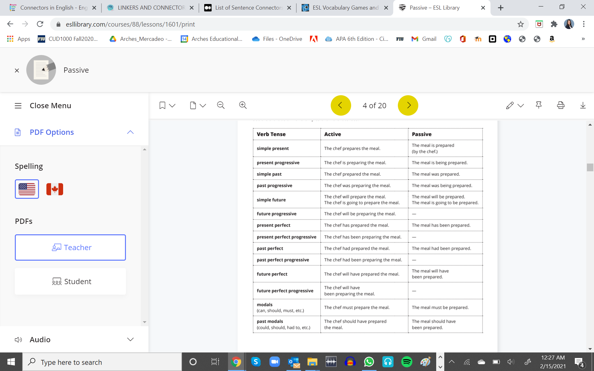

**6.1. Exercise**

**Directions:** Change the following sentences into passive in oral form.

a) Science should answer many questions about artificial intelligence.

b) Artificial intelligence has demonstrated the power of technology.

c) People have invented intelligent machines for many years.

d) Science associates the name of Alan Turing to artificial intelligence.

e) After all, machines cannot substitute the human intelligence.

f) A chess program beat a human for the first time in 2005.

g) Many industries are incorporating artificial intelligence into their work.

h) Universities have done research in the field of artificial intelligence.

f) Faculty members in prestigious universities are carrying out major artificial intelligence experiments.

g) Some US government agencies are providing funds to the experiments.

h) The media has made artificial intelligence innovations public.

i) The movie industry has made several films about artificial intelligence.

j) People classify artificial intelligence movies as science fiction.

k) People are already buying tools with artificial intelligence traits.

l) Humans does not guide many of today’s “intelligent machines”.