**Level:** Pre-A1

**Lesson:** When is your birthday?

**Language Focus:** Talking about dates (months, ordinal numbers, years.)

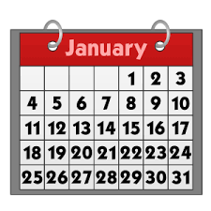

**Warm up** (5 min)

* Do you know how to say “dates” in English?
* For example, when is your birthday?

**1.** **Vocabulary** (5 min)

**Directions**: With the help of your teacher, get familiar with the meaning and pronunciation of the following nouns. Pay closer attention to the “th” sound.

* birthday /ˈberzh-deɪ/ (Spanish: *cumpleaños*)
* date /deɪt/ (Spanish: *fecha*)
* date of birth /ˈdeɪ-rov-ˈberzh/ (Spanish: *fecha de nacimiento*)
* month /monzh/ (Spanish: *mes*)

**2. Listening** (10 min)

**Directions:** Listen to four conversations and answer the questions below:

**2.1.** What are the people talking about?

**A.** Today’s date

**B.** People’s birthdays

**C.** Holidays

**2.2.** Listen again and say the four dates that are mentioned in these conversations. We recommend that you take notes.

**3. Pronunciation Practice: Transcripts** (5 min)

**Directions:** Under your teacher’s supervision,read the transcripts out loud for pronunciation assessment.

**1.**

**Her:** What’s your date of birth?

**Him:** It’s March 14th, 1977.

**2.**

**Her:** What’s your sister’s date of birth?

**Him:** It’s May 28th, 1988.

**3.**

**Her:** What’s your brother’s date of birth?

**Him:** It’s Sep 2nd, 1962.

**4.**

**Her:** Yu Pin, when is your birthday?

**Him:** My birthday is July 29th.

**4. Saying the Date in English** (25 min)

**4.1. Order of Days and Months When Saying the Date** (10 min)

In spoken American English, people usually use the following structure to say the date: *month + day, year*. Example: December 25th, 2019.

|  |  |  |
| --- | --- | --- |
| **Saying the Date** | | |
| **Month** | **Day (Ordinal Numbers)** | **Year** |
| December | 25th* | 2019 |
| /ˈdɪ-zem-ber/ | (twenty-fifth) | (twenty-nineteen) |

*Notice that ordinal numbers are typically used for dates in spoken English, although in written English you may use a normal (cardinal) number without the -TH or -ST after it.

Years are normally divided into two parts; the first two digits and the last two digits.

2019 is divided into 20 and 19 so you would say twenty nineteen.

* 1975 = nineteen seventy-five
* 1999 = nineteen eighty-two
* 2017 = twenty seventeen
* 2021 = twenty twenty-one

**4.2. Months of the Year (5 min)**

**Directions:** With the help of your teacher, practice the pronunciation of each month of the year.

|  |  |
| --- | --- |
| **Month** | **Pronunciation** |
| **January** | /ˈyya-niu-éri/ |
| **February** | /ˈfe-bru-éri/ |
| **March** | /martch/ |
| **April** | /ˈeɪ-pril/ |
| **May** | /meɪ/ |
| **June** | /yyun/ |
| **July** | /yyu-ˈlaɪ/ |
| **August** | /ˈo-gōst/ |
| **September** | /sep-ˈtem-ber/ |
| **October** | /ak-ˈtou-ber/ |
| **November** | /nou-ˈvem-ber/ |
| **December** | /dɪ-zem-ber/ |

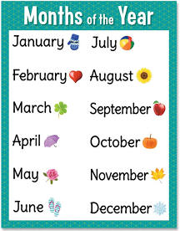

|  |  |  |
| --- | --- | --- |
| **Ordinal Number** | **Number**  **(in letters)** | **Pronunciation Aid** |
| 1st | *first* | /ferst/ |
| 2nd | *second* | /ˈse-kond/ |
| 3rd | *third* | /zherd/ |
| 4th | *fourth* | /forzh/ |
| 5th | *fifth* | /fifzh/ |
| 6th | *sixth* | /sɪkzh/ |
| 7th | *seven* | /ˈse-venzh/ |
| 8th | *eighth* | /eɪtzh/ |
| 9th | *nineth* | /naɪnth/ |
| 10th | *tenth* | /tenzh/ |
| 11th | *eleventh* | /ɪ-ˈle-venzh/ |
| 12th | *twelfth* | /tuelvzh/ |
| 13th | *thirteenth* | /zher-ˈtiinzh/ |
| 14th | *fourteenth* | /for-ˈtiinzh/ |
| 15th | *fifteen* | /fif-ˈtiinzh/ |
| 16th | *sixteenth* | /siks-ˈtiinzh/ |
| 17th | *seventeenth* | /se-ven-ˈtiinzh/ |
| 18th | *eighteenth* | /eɪ-ˈtiinzh/ |
| 19th | *nineteenth* | /naɪn-ˈtiinzh/ |
| 20th | *twentieth* | /ˈtue-ni-ezh/ |
| 30th | *thirtieth* | /ˈzher-ti-ezh/ |

**4.3. Ordinal Numbers (5 min)**

**Directions:** With the help of your teacher, practice the pronunciation of ordinal numbers.

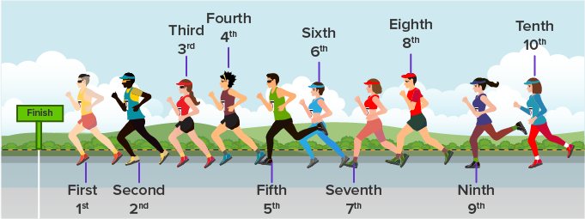

We already know the ordinal numbers: *one, two, three, etc*. However, **ordinal numbers** indicate **order, position**. They are not the same! (*Ya conocemos los números cardinales: uno, dos, tres. Sin embargo, los números ordinales indican orden, posición. ¡No son iguales!*)

**5. Testing your Comprehension: Saying Dates (5 min)**

**Directions:** How would you say the following dates in English?

* 09/13/2018 *September Thirteenth, Twenty-Eighteen._____*
* 03/15/1979 ______________________________________
* 10/24/1986 ______________________________________
* 06/30/2010 ______________________________________
* 01/03/1945______________________________________
* 11/20/2008______________________________________
* 12/11/1998______________________________________
* 05/21/2005______________________________________
* 02/14/1967______________________________________
* 04/06/2001______________________________________
* 08/04/1952______________________________________

**6. Speaking: *Family Birthdays*** (10 min)

**Directions:** In turns, talk about your family birthdays.The following questions may serve as a basis. Make sure to talak about three people at least.



**a)** When is your mother/father’s birthday? Where are your parents from?

**b)** When is your brother/sister’s birthday? How old is she/he? (if applicable)

**c)** When is your son/daughter’s birthday? How old are your children? (if applicable)

**d)** When is your best friend’s birthday? Who’s your best friend?

**e)** Are birthdays special for you?