**Conversation Workshop**

**Recommended Level:** A2+; B1; B2

**Topic:** Television, Movie Theaters and Streaming Services

**Speaking Activity 1: Television**

* Do you enjoy watching TV?
* On average, how much time a day do you spend in front of your TV?
* What’s your favorite kind of show? Sports? News? Cartoons? Soap operas? Why is this specific genre so interesting for you?
* 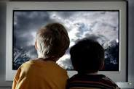Do you watch TV in English? If so, do you believe it helps you enhance your English learning?
* Do you consider television is harmful for children?
* What types of TV programs should we prevent our children from watching?
* In general, what are the advantages and disadvantages of television as a communication means nowadays?

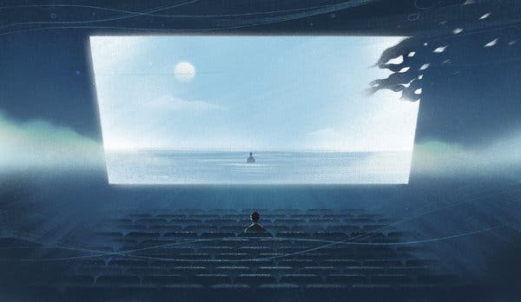**Speaking Activity 2: The Movie Industry**

* Are you a “movie goer”? How often do you go to a movie?
* Do you prefer watching a movie at home or seeing it “on the big screen”?
* What’s your favorite movie genre? And your favorite actor? What makes them so engaging for you?
* Is there any particular movie you consider as “your most watched one”? Tell us about it!
* 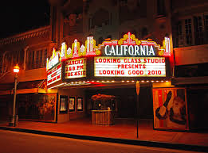What’s the movie industry like in your country of origin? Has it been developed? Does it have international renown?
* Are you a big fan of the “3D and 4D movie” industry? Why?
* Do you watch American movies with subtitles or closed captions?
* How did you feel the first time you went to a movie theater in America? How did you like it?

**Speaking Activity 3: Streaming Services**

* 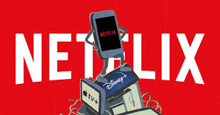In your opinion, what makes streaming such as *Netflix*, *Hulu* or *Prime Video* so successful nowadays?
* Do you pay a premium for any of these services? If so, which one do you pay for?
* 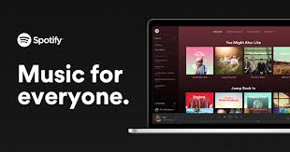Do you think these services might substitute cable TV in the near future? Do you think they somehow threaten old-time TV movie channels, such as *HBO* or *Disney Plus*? Elaborate your answer.
* What about music and radio streaming services, such as *Spotify, Pandora* or *Sirius XM*? Are you an active user of any of them? Do you pay any monthly premium to listen to add-free music or radio?
* Do you use streaming services on your phone?
* In general, how do you like streaming services?