### Topic: Business Matters

**Artificial Intelligence**

# 1. Pre-Reading Activities

## Warm-Up Questions

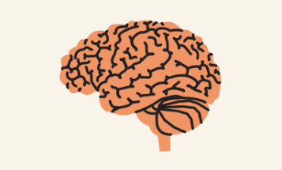

* 1. Discuss what you know about artificial intelligence.
  + Do you believe that machines can behave like humans? Why or why not?
  + What traits do you think humans have that machines do not?
  + Would you like to have a robot? What would your robot do, for example?
  + Have you seen the movies *I, Robot* and *Artificial Intelligence*? If so, discuss what you’ve learned about the films.

## Vocabulary Preview

Match up as many words and meanings as you can.

1.

2.

3.

4.

5.

6.

7.

8.

9.

10.

artificial reasoning capable onslaught tournament

traits

costly faculty

beat ongoing

1. a sudden or large number of people or things
2. teaching staff from one school or department
3. using intelligence and logic to come up with answers
4. defeat
5. able to do something
6. that is active, taking place
7. a sporting or gaming competition with many rounds
8. distinguishing characteristics
9. pricey, expensive

* End of Pre-listening Activities-