**Level:** A1

**Language Field:** Social Interaction

**Lesson:** Buying clothes!

**Grammar:** Simple Present Tense (Statements and Questions)

|  |
| --- |
| In today’s class we’ll talk about clothes shopping! Do you know how to interact in English when you are buying clothes? Do you feel confident when you talk to a sales agent? Let’s practice! |

**WARM UP (10 min)**

**Part A:** *Clothes Vs. Clothing*

What’s the difference between both terms?

'**Clothes**' is a plural noun, used to refer to the garments that you actually wear: pants, shirts, dresses and socks are all *clothes*. '**Clothing**' is a general term that has the same meaning as '*clothes*', but it is used in less personal contexts, such as business and industry.

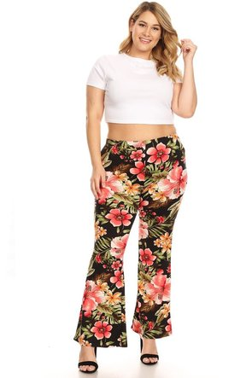**Part B:** *Clothing Sizes*

|  |  |
| --- | --- |
| **Size** | **Pronunciation** |
| ***XS*** | extra small |
| ***S*** | small |
| ***M*** | medium /ˈmɪ-rɪum/ |
| ***L*** | large /lardch/ |
| ***XL*** | extra large |

* What’s your clothing size?
* What’s your top size?
* What’s bottom size?
* Are they the same?
* Do you know the sizes in English?
* Take a look at the size chart!

**1.** **Vocabulary:** **Clothing!**

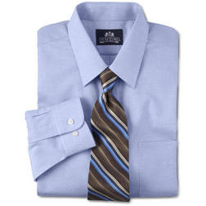**Directions:** Do you know how to name each piece of clothing below? With the help of your teacher, name each article and practice your pronunciation.

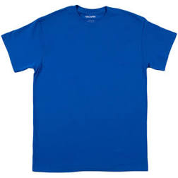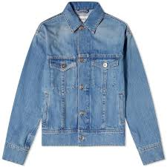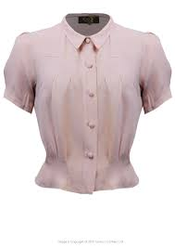

1. ______________ 2. ______________ 3. ______________ 4. ________________

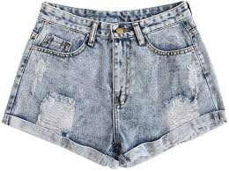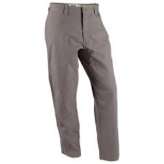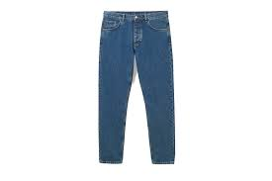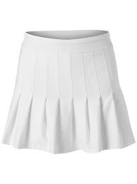5. _______________ 6. _______________ 7. ________________ 8. _________________

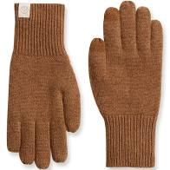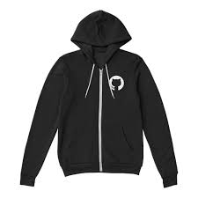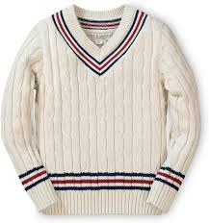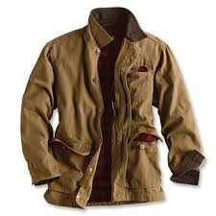

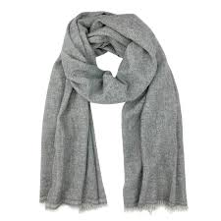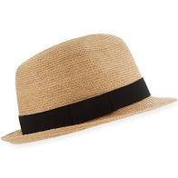 9. _______________ 10. ______________ 11. _______________ 12. _______________

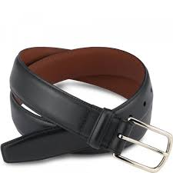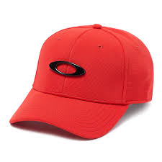11. _______________ 12. _______________ 13. ________________ 14. ________________

**2.** **Listening and Speaking (1):** ***Dress 4 Less* (20 min)**

**2.1.** **Comprehension**

**Directions:** Listen to a store ad and answer the questions below.

**2.1.1. General Comprehension**

**Question:** What is the ad about?

**A.** The store hours.

**B.** The store special deals.

**C.** The store locations.

**2.1.2. Specific Comprehension**

**Question:** How much is each of the following items? For accurate answers in this exercise, we recommending taking notes as you listen.

**a)** socks?

**b)** ties?

**c)** suits?

**d)** dresses?

**e)** skirts?

**f)** sweaters?

**g)** women’s hats?

**2.2.** **Pronunciation Practice: *Ad Transcript***

**Directions:** Under your teacher’s supervision, read the ad transcript out loud for pronunciation assessment.

|  |
| --- |
| *We have very good deals at Dress 4 less! Be sure to come in! Socks are $12.00 dollars, ties are $22.00 dollars, and suits are $285.00 dollars. Our dresses are $48.00 dollars and our skirts are $35.00 dollars. We have great deals on sweaters at $36.00 dollars and women’s hats are $38.00 dollars. Don’t miss our great deals!* |

**2.3.** **Monologue: *Shopping for Clothes!***

**Directions:** Answer the following questions in the form of a brief monologue.Feel free to add any information you want.

- Do you like shopping for clothes?

- What’s your favorite store?

- What’s your favorite season for shopping?

- Do you like to buy clothes online or in-store?

- If you really like something, do you buy it at regular price or you wait for a special offer?

- Do you think men also like clothing stores? Or it’s just “a woman’s thing”?

**3.** **Listening and Speaking (2): Shopping for Someone Else!** (25 min)

**3.1. Comprehension**

**Directions:** Listen to a conversation between a man and a sales agent and answer the questions below.

**3.1.1.** **General Comprehension**

**Question:** Why is the man at a clothing store?

**3.1.2.** **Specific Comprehension**

Listen again and answer the following questions:

a) What does the man’s daughter want?

b) What color does the girl like?

c) What’s the girl’s size?

d) Does the father find what he’s looking for?

e) How much does he pay, in the end?

**3.2. Transcript**

**Directions:** Under your teacher’s supervision, read the conversation transcript out loud for pronunciation assessment.Pay closer attention to the blending and flapping instances indicated.

|  |
| --- |
| Blending Flapped *t* or *d* |

**Sales Agent:** Hi! May I help you?

**Customer:** Yes, I nee*d* a gift for my daughter. She wants a blouse.

**Sales Agent:** Ok. We have some nice blouses.What color do you want?

**Customer:** Well, she likes pink.

**Sales Agent:** Great! Wha*t* about this blouse?

**Customer:** Oh, yes! That blouse is nice.Do you have it in a medium?

**Sales agent:** Let me check… yes, we do.

**Customer:** Thanks! And… how much is it?

**Sales Agent:** It’s on sale! It’s $14.99.

**Customer:** Great! Thank you!

**3.3. Conversation: *What’s the question?***

**Directions:** From the given answers, what do you think are the missing questions in this conversation?

**Sales agent:** ____________________________?

**Customer:** Yes, please. I’m looking for a bathing suit.

**Sales Agent:** __________________________?

**Customer:** No, it’s not for me. It’s a gift for my wife.

**Sales agent:** ________________________________?

**Customer:** She likes blue.

**Sales agent:** This one is really beautiful. ____________________________?

**Customer:** Yes, I like it a lot! But… ________________________________?

**Sales agent:** I don’t think we have a medium size, butlet me check.

(some minutes later)

**Sales Agent:** You’re lucky today! Here you have a medium size.

**Customer:** Great! And _________________________?

**Sales Agent**: It’s only 29.99.

**Customer:** That’s super! _____________________________?

**Sales Agent:** Yes, it’s on sale: 40% off.

**Customer:** _____________________________?

**Sales Agent:** Yes, we accept all credit cards.

**4. Monologue: *Shopping for Someone Else!***

**Directions:** Answer the following questions in the form of a brief monologue. Feel free to add extra information.

* Do you think it’s easy to buy clothing for someone else (when the person is not present?
* Do you know the sizes of all the people in your family (mother, father, siblings, children)?
* When you want to buy a present for a friend or family, do you buy clothing? If not, what do you like to give?
* What about you? Do you like to buy your own clothing? Or do you prefer other people to buy it for you?