**Lesson: The Social Dilemma**

**Text Source:****The Social Dilemma | Official Trailer | Netflix**

**Text Source:** <https://www.youtube.com/watch?v=uaaC57tcci0>

**Grammar Focus: Use of Passive Voice**

1. **Warm Up**
2. What do you think about this statement?

*“If you're not paying for a product, you're the product” and “our attention is the product”.*

1. Do you think that we are constantly being manipulated or persuaded by the media?
2. What do you mainly use Google for?
3. **Vocabulary**

* **be tracked (v. ph.): be** checked, followed
* **facebook-like button (n. ph.):** button to approve any statement of picture in your Facebook app
* **meaningful (adj.):** important, relevant
* **naïve (adj.):** simple-minded, innocent
* **flipside** of a coin (n. ph.): the other side of the coin
* **get rewarded:** to be paid or compensated by
* **thumbs up:** approval signal (with your hand´s thumb)
* **conflate (v.):** combine, mix, blend
* **triggering (adj.):** provoking, inducing, starting
* **awareness (n.):** knowledge of perception
* **clueless (adj.):** having no knowledge or understanding
* **bombarded (adj.):** attacked, bombed
* **entitled (adj.):** believed to be deserving of privileges or special treatment

* **checkmate (n. ph.):** in the game of chess, a check from which a king can´t escape.

1. **Reading Comprehension (Text Transcript)**

**Directions:** Under your teacher’s supervision, read the following excerpts out loud for pronunciation purposes. What do you think the author means by the highlighted phrases?

When you go to google and type in: "*Climate Change is*", you are going to see different results depending on where you live, and the particular things GOOGLE knows about your interests. **That's not by accident. It's a designed technique.** What I want people to know is that everything they are doing online is being watched, it's being tracked. **Every single** **action you take is carefully monitored and recorded**. A lot of people think that GOOGLE is just a search box, and Facebook is just a place to see what my friends are doing. But they don't realize **there is an entire team of engineers whose job is to use your psychology against you.**

*I was the co-inventor of the Facebook-like button.*

*I was the president of Pinterest-GOOGLE-Twitter-Instagram.*

*There were meaningful changes happening around the world because of these platforms.*

*I think we were naive about the flipside of that coin.*

We get rewarded by hearts, likes, thumbs up, and we conflate that with value, and we conflate it with truth. **A whole generation is more anxious, more depressed.**

*I always felt like fundamentally it was a force for good.* ***I don't know if I feel that way anymore.***

Facebook discovered that **they were able to affect real-world behavior and emotions without ever triggering the users' awareness.** They are completely clueless.

**Fake news spreads six times faster than true news.** We are being bombarded with rumors. If everyone is entitled to their own facts, there is really no need for people to come together. In fact, there is really no need for people to interact.

We have less control over who we are and what we really believe. **If you want to control the population of a country, there has never been a tool as effective as Facebook.**

**We built these things, and we have a responsibility to change it.** The intention could be, "How do we make the world better". If technology creates mass chaos, loneliness, more polarization, more election hacking, more inability to focus on the real issues, we're toast. **This is checkmate on humanity.**

1. **Grammar: Passive Voice Review**

|  |
| --- |
| We can see in this transcript how the passive voice is repeatedly used. **The Passive voice** shows that the subject is receiving the action of the verb. Form the passive voice by using the appropriate form of **to be** and **the past participle of the main verb**. That is the most difficult part because you have to memorize them, especially the past participles of the irregular verbs.  In the English speech the passive voice is more used than the active voice in many expressions. Many times, we already know who the doer/subject of the action is; so, we do not need to say who did what or we may even ignore who the subject of the action is. We can find the passive voice expressed in the News, for example. |

**4.1. Grammar in Context** (Orally)

**Directions:** *Change the voice in the following sentences (from the active voice to the passive voice, and viceversa). Be sure to keep the original verb tense in each case.*

a) You are going to see different results depending on where you live.

b) Everything they are doing online is being watched, it's being tracked.

c) Every single action you take is carefully monitored and recorded.

d) A lot of people think that GOOGLE is just a search box.

e) We get rewarded by hearts, likes, thumbs up.

f)Fake news spreads six times faster than true news.

g) We are being bombarded with rumors.

h) We built these things.

i) Technology creates mass chaos, loneliness, more polarization, more election hacking.

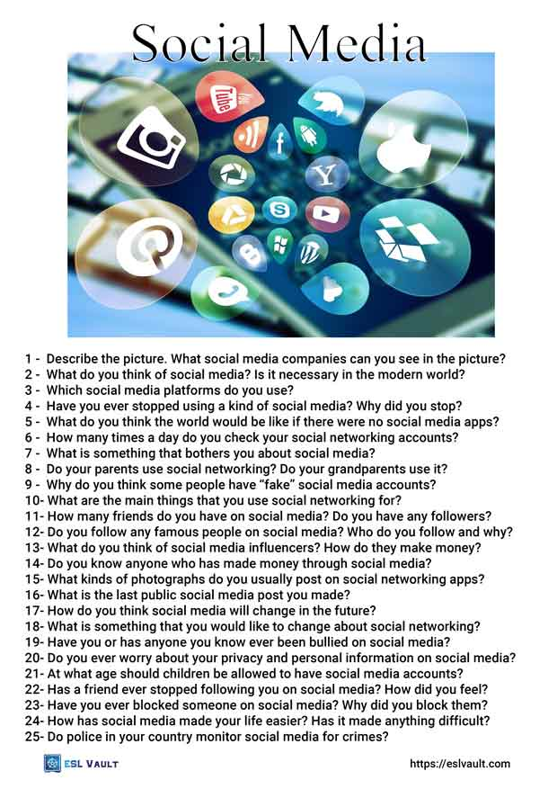**6. Speaking: Monologue**

**Directions:** Answer the following questions in the form of a brief monologue. Feel free to add any information you consider relevant to your presentation.

