**Listening and Speaking Practice**

**Level: A1**

**Lesson Topic: Describing People**

**Warm Up (5 min)**

How would you translate the questions in the following conversations?

|  |  |
| --- | --- |
| **Conversation 1** | **Conversation 2** |
| A. *What’s your brother like*?  B. He’s tall and thin. | A. *How’s your brother*?  B. He’s fine. Thank you. |

Notice that in the first conversation, Character A is asking about a person’s physical appearance, while in the second conversation Character A is asking about a person’s status.

In today’s lesson, we’ll learn to ask and give information about a person’s physical appearance.

**1. Vocabulary: Describing People (10 min)**

**Directions:** Under your teacher’s supervision, study the following vocabulary before you learn to describe people.

|  |  |  |  |
| --- | --- | --- | --- |
| **Item** | **Description** | **Examples** | **Spanish** |
| **Height** | tall /tol/ | She/he is tall. | *alto(a)* |
| short | She/he is short. | *bajito (a)* |
| average-height /ˈa-vrɪdch haɪt/ | She/he is average-height. | *de mediana estatura* |
| **Hair Type** | straight /streɪt/ | She/he has straight hair. | *lacio* |
| wavy /ˈweɪ-vɪ/ | She/he has wavy hair. | *ondeado* |
| curly /ˈker-lɪ/ | She/he has curly hair. | *risado* |
| **Hair Length** | long | She/he has long hair. | *largo* |
| short | She/he has short hair. | *corto* |
| shoulder length /lenzh/ | She wears a shoulder length. | *a la altura de los hombros* |
| **Hair Color** | dark | She/he has dark hair. | *oscuro, negro* |
| blond | She is blond.  She/he has blond hair. | *rubio(a)* |
| gray /greɪ/ | She/he has gray hair. | *con canas* |
| **Eye Color** | dark brown | She/he has dark brown eyes | *oscuros* |
| light brown | She/he has light brown eyes. | *castaño claro* |
| blue | She/he has green eyes. | *azules* |
| green | She/he has green eyes. | *verdes* |
| **Body Shape** | thin /zhɪn/ | She/he is thin. | *flaco* |
| fit | She/he is fit. | *en forma* |
| heavy /ˈhe-vɪ/ | She/he is heavy. | *gordo(a)* |
| **Face Hair** | beard /biird/ | She/he has a beard. | *barba* |
| mustache /ˈmos-tash/ | She/he has a mustache. | *bigote* |

**2. Listening Comprehension (10 min)**

**A.** Which person is the boy describing?

**B.** Listen again and answer these questions:

**a)** Is the boy’s family in the United States?

**b)** What does he do for work?

**c)** Is he funny?

**d)** Does the boy look like his brother?

**e)** What’s the boy’s brother like?

**f)** Is the boy’s brother married?

**3. Pronunciation Practice: Say it accurately**

**Directions:** Practice reading the conversation transcript out loud. What do you think the underlined phrases mean?

**Girl:** Is your family here in this country?

**Boy:** My brother is here. He’s a carpenter.

**Girl:** Oh, what’s he like?

**Boy:** He’s great. He’s a lot of fun!

**Girl:** Does he look like you?

**Boy:** No, he’s tall and thin… and has long hair. Here’s a picture of him.

**Girl:** Oh, he has a beard and a mustache, too.

**Boy:** He has one more thing.

**Girl:** Oh, yeah? What’s that?

**Boy:** He has a wife.

**4. Grammar in Context:** Which is the correct sentence?

**Directions:** From the given options (A & B), select the correct sentence.

**1.**

A. He has beard

B. He has a beard.

**2.**

A. Does he look to you?

B. Does he look like you?

**3.**

A. He doesn’t have a mustache.

B. He doesn’t have mustache.

**4.**

A. She has eyes dark brown.

B. She has dark brown eyes.

**5.**

A. They have long hair.

B. They has long hair.

**6.**

A. My mom wears a shoulder length.

B. My mom has shoulder length.

**7.**

A. He is average-height.

B. He has average-height.

**5.** **Vocabulary: Say it another way.**

**Directions:** Say each of the following sentence some other way. The first example has been done for you.

a) Her hair is dark and long.

**Answer:** *She has dark long hair.*

b) His eyes are big and blue.

________________________________________

c) Her hair is blond.

________________________________________

d) Their hair is black and curly.

________________________________________

e) His eyes are small and green.

________________________________________

f) His hair is red and short.

_________________________________________

g) He has a fit body.

_________________________________________

**6. Speaking**

**6.1. Describing People**

**Directions:** In turns, describe the people in the pictures orally. Feel free to include extra information to make your descriptions more interesting.

**Example:** *Samuel has red short hair and blue eyes. He has a mustach and a beard. He’s very smart, but shy. He is average-height.*

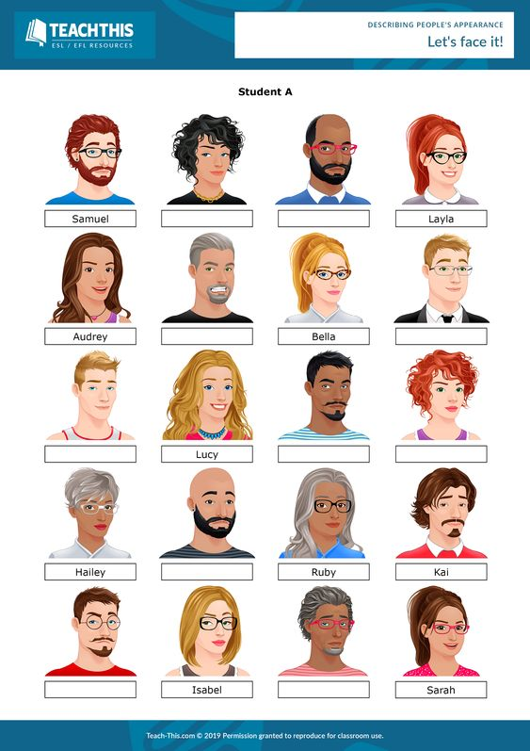

**6.2. Monologue**

**Directions:** Think about someone you know: a friend, a family member. Then, describe him/her in details. The following questions may serve as a basis.

a) What’s his/her full name?

b) Where is she/he from?

c) What does she/he do for work?

d) How old is she/he?

e) Is he/she tall, short, average-height?

f) What is his/her hair like?

g) What are his/her eyes like?

h) What’s his/her personality like? Is he/she smart, funny, nice?