**Conversation Workshop:** Technology in Our Lives

**Level:** B1 B2

**Lesson Aids:** You Tube Videos on The Lesson Topic

* <https://www.youtube.com/watch?v=dwAuTbx3xKE>
* <https://www.youtube.com/watch?v=U2gQE0J00UE>

**Activity 1: Technology and Gender**

**Video:** Emma and Technology

**Directions:** Watch the video and answer the following questions:

**a)** What story does the video tell us about?

**b)** Are you an active user of technology? What do you use technology for?

**c)** Do you think technology can simplify every-day processes through automation? Elaborate your answer through examples.

**d)** Do you agree with the idea that men tend to be better at technology than women? Why?

**Activity 2: Technology & Age**

**Video 2:** iPad for Grandpa

**Directions:** Watch the video and answer the following questions:

**a)** What does the video tell us about?

**b)** Do you think technology is meant for young people only? In your opinion, is there any relation between technology and age?

**c)** Do you know senior people who are good at technology? Tell us about them!

**d)** Have you ever given any technological device to your parents/grandparents? If so, how was their experience?

**e)** When it comes to children, what do you think is the best age frame to expose them to technology?

**Activity 3: Pros and Cons of Social Media on Young People**

**From:** <https://www.familyorbit.com/blog/pros-and-cons-of-social-media/>

**Directions:** Look at the pros and cons of social media on teenagers presented in the following chart.

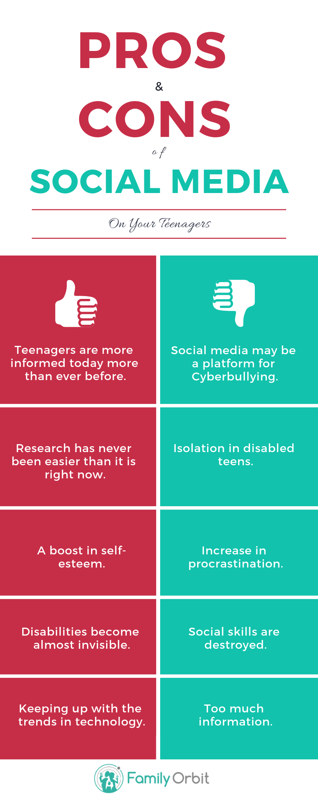**Questions:**

a) How did social media change our lives?

b) Do you agree with all of the points presented herein?

b) Is there any other bright side or downside of social media not being mentioned in the chart?

c) In your case, how do you use social media every day (if applicable)?

d) In your opinion, what could be a “smart use” of social media in our lives?