**Curriculum Support (Review Lessons)**

**Level: Pre A1**

**Lesson: 6 (My friend’s name is Jane)**

**Language Focus: Speaking**

**Grammar Focus: Possessive Nouns**

**Warm Up**

Talking about **people’s height** in English.

**Question:** What is this man’s height /haɪt/?

How tall is he?

**Answer:** He’s *5’’ 6’ tall*.

What about you?

What’s your height?

How tall are you?

* 5’’ = 5 feet /fiit/
* 6’ = 6 inches

**1. Speaking** *-* ***People’s IDs*** (10 mins)

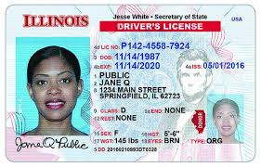**Directions:** Talk about the following people from the information on their ID. The first example has been done for you.

***This is Jane.***

* Jane’s last name is Public.
* Jane’s address is 1234 Main St., Springfield, Illinois.
* Jane’s date of birth is Nov 14th, 1987.
* She is 33.
* She is 5’ 6’’ tall.
* She has brown eyes.



***This is Janice.***

(What can you tell about Janice?)

***This is John.***

(What can you tell about John?)

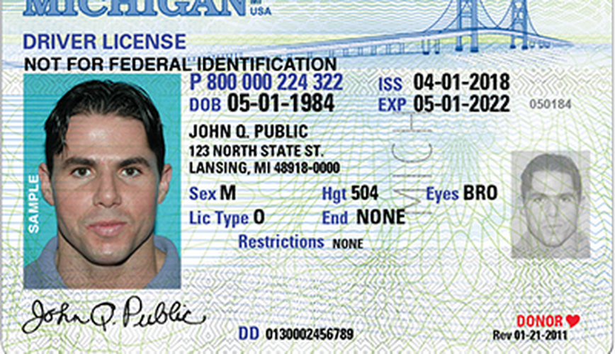

**2.** **Reading: Patrick’s Family (15 min)**

**Directions:** Under your teacher’s supervision, read out loud about Patrick’s family. Can you identify the people that correspond in boxes 1 to 5?



**2.1. Reading Comprehension**

**Directions:** Answer the following questions about Patrick’s family.

**a)** Who is Patrick’s wife?

**b)** What is Brenda’s occupation?

**c)** Who is Patrick’s daughter? How old is she?

**d)** What is Laura’s occupation?

**e)** Who is Patrick’s son? How old is he?

**f)** What is Brian’s occupation?

**g)** Who’s Laura’s boyfriend?

**h)** What’s Mike’s occupation?

**2.2. Grammar in Context – *Possessive Nouns***

**Directions:** In the paragraph above, there are three possessive nouns. Can you identify them?

1. _________________________

2. _________________________

3. _________________________

What do possessive nouns express? Are they difficult for you? Why?

**2.3. Spanish-English Translation – *Using Possessive Nouns***

**Directions:** How would you re-express the following sentences from Spanish into English?

a) La familia de Patrick no es grande.

b) Los hijos de Patrick son Laura y Brian.

c) La esposa de Patrick es americana.

d) El esposo de Laura es enfermero, también.

e) El hijo de Patrick es estudiante.

f) La novia de Brian no está en la foto.

**3. Speaking: Mike’s Family (10 min)**

This is Mike, Laura’s husband (from previous activity).

Let’s learn more about Mike! Below you’ll find more information about his family and friends! The first item has been done for you as an example.

|  |
| --- |
| **Example:**  *She’s Sheila. She’s Mike’s sister.*  *She is 24.*  *She is married. She has 1 daughter: Melanie.*  *Sheila is an office assistant.*  *She is in San Francisco, California.* |

 **Name:** Sheila

**Relationship with Mike:** sister

**Age:** 27

**Status:** married

**Children:** 1 (Melanie)

**Job:** office assistant

**Residence:** San Francisco, CA.

**Name:** Layla

**Relation with Mike:** pet

What can you tell about Layla?

**Breed:** boxer

**Age:** 5

**Residence:** Mike’s house

**Characteristic:** playful, smart.

**Name:** Elisa

**Job:** Teacher

What can you tell about Elisa?

**Relation with Mike:** Teacher

**Job:** Spanish Teacher

**Status:** Single

**Age:** 25

**Origin:** Colombia

**Name:** Richard

**Relationship with Mike:** best friend

What can you tell about Richard?

**Age:** 31

**Status:** divorced

**Job:** Medical Assistant

**Characteristic**: nice, kind.

**Residence:** Chicago, Illinois.

**4. Grammar Review: Asking Questions with Verb BE** (5 min)

**Directions:** Write possible answers to the following questions.

**a)** ______________________________________________

Answer: Sheila is 27.

**b)** ______________________________________________

Answer: Yes, Sheila is married.

**c)** ______________________________________________

Answer: Layla is at home with Mike.

**d)** ______________________________________________

Answer: Elisa is from Colombia.

**g)** ______________________________________________

Answer: No, Elisa is a Spanish teacher.

**h)** ______________________________________________

Answer: Yes, Richard is very nice.

**5. Speaking: Monologue** (5 mins)

**Direction:** What are the names in your family? In turns, talk about your relatives’ names. Feel free to include any information you want to make your presentation more interesting. Use possessive nouns in your answer, as in the example.



*My father’s name is…*

*My sister’s name is…*

*My nephew’s name is…*